Using a Haptic Belt to Convey Non-Verbal Communication Cues   
during Social Interactions to Individuals who are Blind

Troy McDaniel, Sreekar Krishna, Vineeth Balasubramanian, Dirk Colbry and Sethuraman Panchanathan

Center for Cognitive Ubiquitous Computing (CUbiC)

School of Computing and Informatics (SCI)

Arizona State University, Tempe AZ 85281

Abstract – Good social skills are important and provide for a healthy, successful life; however, individuals with visual impairments are at a disadvantage when interacting with sighted peers due to inaccessible non-verbal cues. This paper presents a haptic (vibrotactile) belt to assist individuals who are blind or visually impaired by communicating non-verbal cues during social interactions. We focus on non-verbal communication pertaining to the relative location of the communicators with respect to the user in terms of direction and distance. Results from two experiments show that the haptic belt is effective in using vibration location and duration to communicate the relative direction and distance, respectively, of an individual in the user’s visual field.

Keywords – Haptic Display, Tactile Display, Haptic Belt, Tactile Cues, Vibrotactile Cues, Social Interaction, Non-verbal Communication, Assistive Technology.

I. INTRoduction

1. Non-Verbal Cues for Social Interaction

People participate in social interactions every day with friends, family, co-workers and strangers. A strong set of social skills is critical in life—for example, they help us make new friends or make good first impressions at job interviews. Good social skills begin to develop at an early age and are essential for social development and acceptance, helping individuals lead normal, healthy, successful lives [1]. Social interactions involve both verbal (auditory) and non-verbal (visual) communication cues. Most of the time, verbal and non-verbal communications are so intertwined that we hardly notice the difference.

Non-verbal communication consists of a variety of cues [2]: physical environment (context provided by the environment, distance between communicators, etc.); appearance of communicators (physique, clothing, hair style, etc.); and physical movement (gestures, posture, facial expressions, eye movements, etc.). In an average conversation between two people, about 65% of the communication is non-verbal [3]. People who are blind cannot independently access this visual information, putting them at a disadvantage in daily social encounters. For example, during a group conversation it is common for a question to be directed to an individual without using his or her name—instead, the gaze of the questioner indicates to whom the question is directed. In such situations, people who are blind find it difficult to know when to speak because they cannot determine the direction of the questioner’s gaze. Consequently, individuals who are blind might be slow to respond or talk out of turn, possibly interrupting the conversation. As another example, consider that people who are blind cannot use visual cues to determine when their conversation partners change positions (e.g., pacing the floor or moving to a more comfortable chair). In this scenario, an individual who is blind might inadvertently create a socially awkward situation by speaking in the wrong direction.

To compound these problems, sighted individuals are often unaware of their non-verbal cues and often do not (or cannot) make appropriate adjustments when communicating with people who are blind. Also, people who are blind often do not feel comfortable asking others to interpret non-verbal information during social encounters because they do not want to burden friends and family. The combination of all these factors can lead people who are blind to become socially isolated [4], which is a major concern given the importance of social interaction.

Specialized training is available to help individuals who are blind in learning to convey appropriate non-verbal cues (such as maintaining a proper posture, avoiding back-and-forth rocking motions, or selecting coordinated clothing). While this training is helpful, assistive technology is still required to allow individuals who are blind to independently perceive non-verbal cues. While many assistive devices have been developed to meet a wide range of needs of people who are blind, not enough attention has been given to the development of assistive devices that satisfy the need for access to non-verbal communication in social interactions.

1. Social Interaction Assistant

While advances in computer vision have opened up possibilities for assistive devices for social interaction, there has been little effort to understand the social interaction needs of individuals who are blind. We met with focus groups (composed of disability experts and individuals who are blind or visually impaired) who helped identify several key needs of the visually impaired community, one being the need to recognize people they encounter during the day. Based on this need, we developed the Social Interaction Assistant [5, 6]: a computer vision-based, wearable assistive device for face recognition for individuals who are blind. The main components of this system include a pair of sunglasses with an embedded camera, a computing element, and a speaker to output the name of a person recognized by the Assistant. When a person comes within the visual field of the camera, his or her face is detected using rectangular filters found through adaptive boosting [7] and the extracted face image is then sent to a recognition engine, which associates a name for the detected face to the best match from a stored face database. If the user encounters a person not yet in the database, images of the person’s face can be captured and added to the face database.

1. Important Non-Verbal Cues

To validate the lessons learned from our focus groups, we conducted an online survey of individuals who are blind or visually impaired to better understand their needs for support during social interactions. Combining the survey results with the initial focus group discussions, we identified several key types of non-verbal information that people who are blind may need to access during social encounters: (1) the number of people standing in front of the user, and where each person is standing; (2) where a person is directing his or her attention; (3) the identities of the people standing in front of the user; (4) the appearance of the people standing in front of the user; (5) whether the physical appearance of a person, whom the user knew before, has changed since the last time the user encountered him or her; (6) the facial expressions of the person standing in front of the user; (7) the hand gestures and body motions of the person standing in front of the user; and (8) if the user’s personal mannerisms might not fit the behavioral norms and expectations of the sighted people with whom they may interact.

1. Motivation

An important shortcoming of our Social Interaction Assistant [5] (and many other assistive devices for individuals who are blind) is that the prototype Assistant provides only audio outputs. This design is not practical for the target user population because individuals who are blind rely on their ears to perceive their environment, and audio outputs may interfere with normal hearing. This paper describes an alternative delivery modality: a vibrotactile belt that can convey non-verbal communication cues to individuals who are blind or visually impaired. Specifically, we focus on the first non-verbal cue listed in Section I.C: helping users perceive the *number* of people in their visual field, and the relative *direction* and *distance* of each individual with respect to the user. In some social situations, location information is available through audible cues, but this is not always the case. For example, when a group of friends approaches all of them may smile but only some may offer a verbal greeting, or a passing co-worker may nod to you in the hallway without exchanging a verbal greeting. These non-verbal communications are common occurrences, but are not accessible to someone who is blind.

Section II summarizes related work while Section III covers the system architecture. Section IV presents our experimental methodology and discusses our results. Finally, in Section V, we conclude the paper and present possible directions for future work.

II. background and related work

Vibrotactile cues are vibratory signals defined by signal frequency, intensity, rhythm, and duration [8] of the vibration in contact with the human body. Vibrotactile cues have found uses in a variety of application areas including human navigation [9-11], human spatial orientation [12-13], human postural control [14] and human communication [8]. The idea of using vibrotactile cues on a haptic belt for information delivery is not a new idea. However, the use of vibrotactile cues for non-verbal communication during social interactions is novel and provides an exciting opportunity to provide assistance with daily tasks to individuals who are blind. This section introduces several approaches for using vibrotactile belts to convey navigation and/or orientation information, which inspired the design of our haptic belt.

In an early haptic navigation system for individuals who are blind [9], Ertan *et al.*, proposed a tactile display (worn on the back) consisting of a 3x3 array of tactors that convey directional information through pulsing columns and rows. In [10], the authors proposed the ActiveBelt, a haptic belt to guide the user to a destination using eight tactors placed around the waist, a GPS unit and an orientation sensor. Another system for human navigation is a tactile vest proposed by Jones *et al.* [11], which utilizes a 3x3 array of tactors placed on the back to convey directional information.

Another application of vibrotactile cues is the Tactical Situation Awareness System (TSAS) [12], which is a tactile suit designed to help reduce spatial disorientation that is sometimes experienced by pilots in flight due to a lack of visual cues. The TSAS uses vibrations to indicate critical information such as the direction of the gravity vector. Similarly, tactile displays have been developed to help astronauts compensate for spatial disorientations [13]. Finally, tactile display devices have been developed to assist people with damage to their vestibular system. For example, in [14], balance control is achieved using a haptic belt system composed of a tilt sensor and three rows of tactors used to indicate body tilt information.

These examples of information transfer through vibrotactile devices prove the capability of a haptic belt to communicate specific navigation or orientation information. They also validate the general ability of humans to access and interpret feedback provided by vibrating tactors. In the next section, we describe the system architecture of the haptic belt designed and used in all our experiments.

III. SYSTEM ARchitecture

1. Hardware Design and Implementation

The haptic belt that we designed is based on the experiments carried out by Cholewiak, *et al.* [15]. They tested the ability of users to localize vibrotactile cues with different haptic belt designs varying in the number of tactors (6, 7, 8 or 12) and in the arrangement of tactors (tactors placed around the full length of the waist or tactors placed in a semicircle around the waist). In all their experiments, Cholewiak, *et al.* [15] found that having fewer tactors helped users localize vibrations more accurately. For example, although localization accuracy was poor with a 12 tactor belt encircling the entire waist, accuracy greatly improved when fewer tactors (semicircle of 7 tactors) were used even though tactor separation remained the same. They also tested centering the 7 tactor belt at different locations on the waist such as the navel, spine or sides; of these locations, the navel and spine gave the best results.

Based on these studies, we designed our belt with 7 equidistantly spaced tactors in a semicircle such that inter-element spacing—when the elastic band of the belt is not stretched—is 3 inches (7.62 cm), the center tactor is on the navel, and the two end tactors are on either sides of the waist. Figure 1 shows the prototype haptic belt, which is designed to be worn under regular clothing. The control box is worn toward the user’s spine and a cable connects the control box to a PC’s parallel port. As part of future work, we are working on a wireless version of this belt, which will allow users to move around freely.

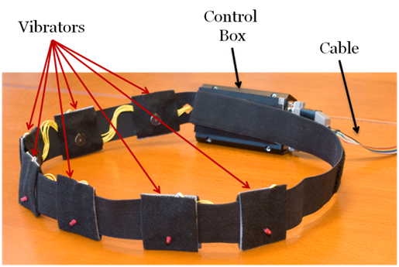

Figure 1: Haptic Belt

Figure 2 depicts the construction of each tactor on the belt. We used pancake cell phone vibratory motors, which have a contact area of 2.25 in2 (14.51 cm2) and operate at 3 V and 70 mA. Each of the motors is installed on a perforated board along with an LED used as a visual indicator for debugging and testing. The perforated board itself was tied to a square piece of plastic canvas frame. The vibratory elements were joined with an elastic band that provides flexibility, ease of use and adaptability to different users. The motors themselves were connected using flexible multi stranded wires that allow for expansion and contraction of the belt around the waist. The control unit for the belt consisted of 7 opto-isolators controlled via 7 bits of a PC parallel port (LPT). The actuation of the tactors is controlled through software that turns the bits of the parallel port high or low. (Use of Bluetooth for tactor activation will replace this mode of operation in the wireless version of the belt.)

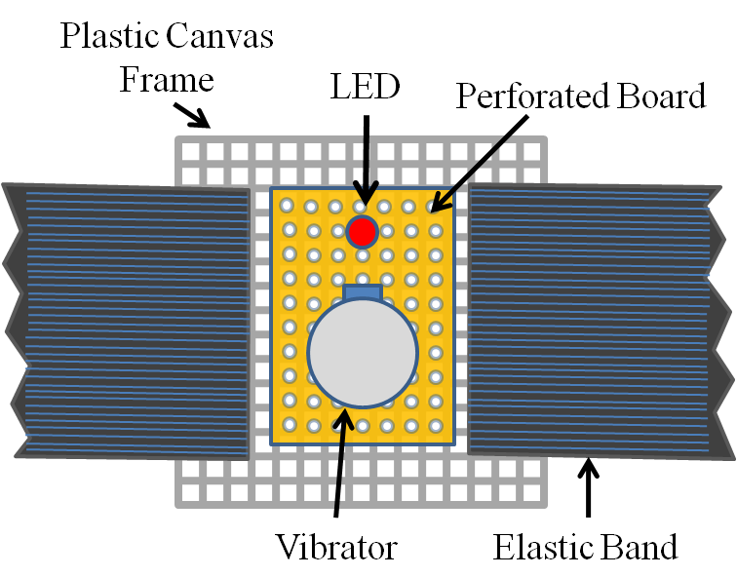

Figure 2: Individual Elements of the Haptic Belt

1. Software Design and Implementation

Existing computer vision techniques for face detection [7] can provide a wealth of non-verbal cues for social interaction, including the number of people in the user’s visual field, where people are located relative to the user, coarse information related to gaze direction (pose estimation algorithms could be used to extract finer estimates of pose), and the approximate distance of the person from the user based on the size of the face image. We leverage the existing framework on our Social Interaction Assistant [5] to obtain all the above mentioned cues.

As shown in Figure 3, the output of the face detection process (indicated by a green rectangle on the image) provided by the Social Interaction Assistant is directly coupled with the haptic belt. Every frame in the video sequence captured by the Social Interaction Assistant is divided into 7 regions. After face detection, the region to which the top-left corner of the face detection output belongs is identified (as shown by the star in Figure 3). This region directly corresponds to the tactor on the belt that needs to be activated to indicate the direction of the person with respect to the user. To this end, a control byte is used to communicate between the software and the hardware components of the system. Regions 1 through 7 are coded into 7 bits on the parallel port of a PC. Depending on the location of the face image, the corresponding bit is set to 1. The software also controls the duration of the vibration by using timers. The duration of a vibration indicates the distance between the user and the person in his or her visual field. The longer the vibration, the closer the people are, which is estimated by the face image size determined during the face detection process.

An overall perspective of the system and its process flow is given below. When a user encounters a person in his or her field of view, the face is detected and recognized (if the person is not in the face database, the user can add it). The delivery of information comprises two steps: Firstly, the identity of the person is audibly communicated to the user (we are currently investigating the use of tactons [8] to convey identities through touch, but this is part of future work). Secondly, the location of the person is conveyed through a vibrotactile cue in the haptic belt, where the location of the vibration indicates the direction of the person and the duration of vibration indicates the distance between the person and the user. Based on user preference, this information can be repeatedly conveyed with every captured frame, or just when the direction or distance of the person has changed. The presence of multiple people in the visual field is not problematic as long as faces are not occluded and can be detected and recognized by the Social Interaction Assistant. We are currently investigating how to effectively and efficiently communicate non-verbal communication cues when the user is interacting with more than one person.

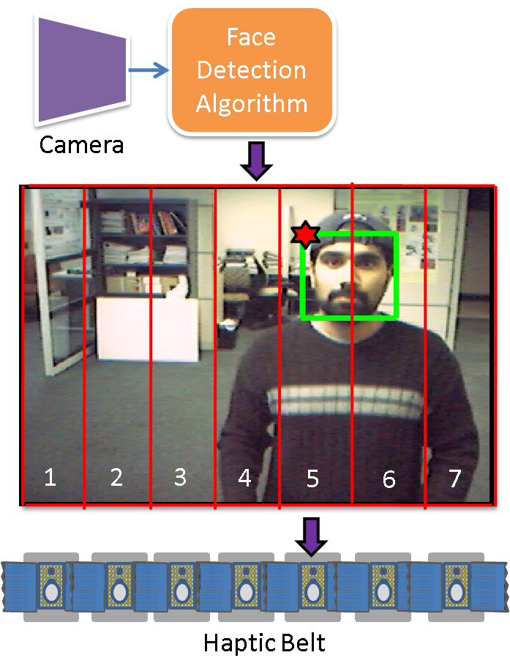

Figure 3: System Architecture for Haptic Belt used as part of the Social Interaction Assistant

IV. experimental methodology

The experiments presented here tested the haptic belt system for its use in conveying non-verbal cues, specifically cues pertaining to where communicators are located with respect to the user in terms of *direction* (Experiment 1) and *distance* (Experiment 2). We choose to focus on locating communicators as a first step towards eventually providing a variety of non-verbal social cues.

Although we have successfully controlled the haptic belt using the Social Interaction Assistant, we chose to have an experimenter control the haptic belt for all of the experiments described here. This setup allowed us to focus on accurately assessing the capabilities of the haptic belt. Future experiments (see Section V) will investigate the capability of the combined system in conveying additional non-verbal cues, such as gaze direction, and will include extensive usability testing of the system by individuals who are blind.

1. Experiment 1: Localization of Vibrotactile Cues

Prior work [15] showed that reasonable localization accuracy—between 80% to 100% accuracy depending upon tactor location—was possible with a belt design similar to what we presented above. Our experiment is similar, but offers a few variations to verify the results obtained in [15].

**Subjects:** 10 subjects (8 males and 2 females), of ages between 24 and 59, participated in this experiment. One of the subjects was blind; the rest were sighted. Subjects had no known deficits related to their tactile sense of the waist area. Further, no subjects had prior experience with haptic belts, but all subjects had some exposure to vibrotactile cues (e.g., vibrations of a cell phone).

**Apparatus:** The haptic belt described in Section III was used for this experiment. Vibratory signals were 600 ms in length, and had a frequency and intensity well within the range of human perception. In contrast to [15], cues are longer—600 ms compared to 200 ms—and we do not use headphones to mask subtle vibration noise, nor do we randomly vary intensity with each cue; the reason for these changes is that we are mostly concerned with how the belt as a complete system accomplishes non-verbal communication, rather than the spatial acuity of the waist. Hence, if a specific intensity of vibration feels different around the waist, and some vibrations can be heard, and if these cues help in tactor localization, then this redundant information should only add to the usability of the system.

**Procedure:** Subjects put on the haptic belt over their shirt and around their waist such that the middle tactor (#4) was centered at their navel, and the endpoint tactors (#1 and #7) were at their left and ride sides, respectively. As the belt has LEDs that light up to indicate tactor activation (used for testing the belt), subjects were instructed to not look down at the belt any time during the experiment. Next, subjects were familiarized with tactor numbering: the experimenter activated tactors in order from #1 to #7, and spoke aloud the number of the activated tactor. This process was repeated twice for each subject.

The training phase involved 35 trials where each tactor was randomly activated 5 times (with approximately 5 seconds between tactor activations) and subjects had to identify the number of each activated tactor. A visual guide was provided for subjects to help recall tactor numbers; this guide was a white board with a drawing of a semicircle (the belt) and the numbers 1 through 7 (tactors) on the belt. Feedback was given during the training phase to correct wrong guesses. The testing phase was similar to the training phase, but involved 70 trials where each tactor was randomly activated 10 times, and feedback was not provided. Subjects stood during the entire experiment.

**Results:** The localization accuracy for each tactor (number of times identified correctly out of the total number of times activated) was averaged across subjects and is shown in Figure 4 (indicated by the dots centered within each error bar), where error bars indicate 95% confidence intervals. The overall localization accuracy across tactors and subjects was (92.17.0)%.

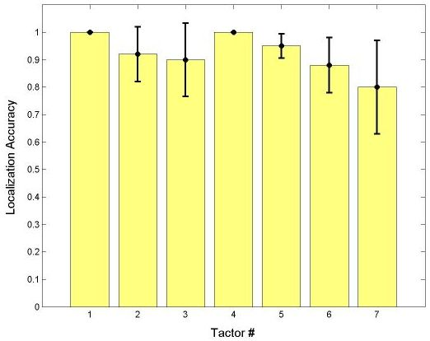

Figure 4: Experiment 1 Results: Mean Localization Accuracy for each Tactor, Averaged across Subjects, with 95% Confidence Intervals

**Discussion:** An overall localization accuracy of (92.17.0)% (an improvement over that of [15]) is promising and shows that our prototype haptic belt can be reliably used to indicate the direction of someone in the user’s visual field. Moreover, 100% of misclassifications were off by a single tactor location; hence, even when users made a mistake in localizing an activated tactor, they still had a very good idea of the general direction of someone in their visual field.

We hypothesize that the increase in accuracy is largely due to greater cue duration (600 ms as opposed to the 200 ms used in [15]); it is well known that larger cue durations make localization easier [16]. Moreover, redundant information provided by the belt, such as subtle audible cues when tactors are activated, could have helped as well. Subjects found tactors closer to the midline easier to localize, which agrees with the results found in the literature where spatial acuity improves near the sagittal plane [15, 16] given that spatial acuity is better at anatomical reference points—in this case, the navel.

It is hypothesized in [15] that the tactors at the end of the semicircle, which rest at the sides of the torso, act as landmarks and are easier to localize; but in our experiments, we noticed that tactor #1 could be localized more accurately than tactor #7, as shown in Figure 4. We are investigating this asymmetric result.

1. Experiment 2: Signal Duration as Cue for Distance

Experiment 2 included two sub-experiments to examine the use of vibrotactile cues to indicate both direction and distance. Experiment 2A focused on how well subjects could perceive cue duration, regardless of tactor location. Experiment 2B tested how well subjects could perceive both tactor location and cue duration at the same time.

**Subjects:** The ten subjects introduced for Experiment 1 also performed Experiment 2A and 2B.

**Apparatus:** The belt and signal properties were identical to those of Experiment 1 with the exception of signal duration. For Experiment 2A and 2B, signal durations of 200 ms, 400 ms, 600 ms, 800 ms and 1000 ms were used. These durations may refer to any distance in the implementation of the system; e.g., less than 2 ft (1000 ms), 2 ft to 4ft (800 ms), 4 ft to 6 ft (600 ms), and so on.

**Procedure:** In the first part of Experiment 2A, subjects were familiarized with the five cue durations. All five durations were delivered to the user at each of the seven tactors from #1 to #7, in order. The training phase for Experiment 2A involved 35 trials where each tactor was randomly activated 5 times (one time for each of the 5 durations) with approximately 5 seconds between tactor activations. Subjects were instructed to guess only cue duration. The testing phase involved 70 trials with each tactor activated twice for each duration. As in the training phase, subjects had to guess the duration of the cue, but no feedback was provided. Immediately following Experiment 2A, subjects began Experiment 2B. First, the familiarization and training phase of Experiment 1 were repeated. The testing phase involved 70 trials similar to 2A, but subjects now had to guess both cue duration and tactor location. As in Experiment 1, subjects stood the entire experiment, had access to a visual guide and were told not to look at the belt.

**Results:** Classification accuracy of duration (number of times identified correctly out of the total number of times used) was averaged across subjects and is shown in Figure 5 (indicated by the dots centered within each error bar), where error bars indicate 95% confidence intervals. Note that the x-axis of Figure 5 lists durations as #1 (200 ms), #2 (400 ms), #3 (600 ms), #4 (800 ms) and #5 (1000 ms). The results for both Experiment 2A and 2B are included in Figure 5. The overall classification accuracy of duration across tactors and subjects was (733.6)% and (6711.8)% for Experiment 2A and 2B, respectively. There were not any noticeable differences in classification accuracy of duration between different tactor locations in either part of the experiment.

**Discussion:** In Experiment 2A, subjects were able to easily identify durations of 200 ms and 400 ms, most likely due to their short length. However, subjects had difficulty distinguishing between 600 ms, 800 ms and 1000 ms. Two subjects suggested that a logarithmic scale of 200 ms, 400 ms, 800 ms, 1600 ms, and so on, might improve recognition. However, longer cues slow down use of the system, making it more difficult to use in real time. Another option would be to use fewer cues (e.g., 200 ms, 500 ms and 1000 ms) to provide only coarse distance information. Regardless, the overall classification accuracy of duration at (733.6)% is impressive, and accuracies for longer durations are satisfactory. The skill of subjects at classifying lengths of vibrations varied, resulting in large variations in classification accuracy for longer cue durations (see Figure 5). In any case, 94.7% of misclassifications were off by only 200 ms (5.3% of misclassifications were off by 400 ms), which shows that subjects were quite accurate with their estimates.

In Experiment 2B, overall classification accuracy of duration dropped to (6711.8)%. We hypothesize that this small drop in mean accuracy, as well as an increase in variance, was due to the cognitive load of having to attend to both vibration duration and tactor location. In any case, overall accuracy is still satisfactory, and 89% of misclassifications were off by only 200 ms (11% of misclassifications were off by 400 ms). Overall tactor localization accuracy for Experiment 2B was (94.35.7)% (averaged across subjects, tactors and durations), which is similar to the localization accuracy of (92.17.0)% found in Experiment 1. Once again, 100% of misclassifications were off by a single tactor location. We conclude that tactor locations are still easy to perceive even when cue length varies and attention must be divided between cue duration and location.

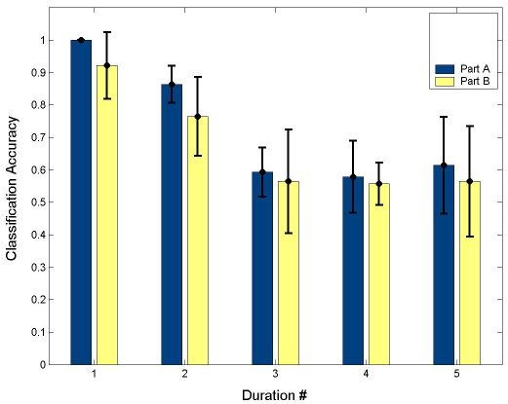

Figure 5. Mean Classification Accuracy of Duration, Averaged across Subjects and Tactors, with 95% Confidence Intervals. Durations listed in figure correspond to 200 ms (#1), 400 ms (#2), 600 ms (#3), 800 ms (#4) and 1000 ms (#5)

V. conclusionS and future work

In this paper, we presented a haptic (vibrotactile) belt for non-verbal communication during social interactions for individuals who are blind or visually impaired. Two experiments were conducted to evaluate the belt’s capability to provide non-verbal cues pertaining to communicators, namely direction and distance. From the results it can be concluded that a haptic belt could be used as an effective mode for communicating information in place of headphones. In the future, we plan to integrate the haptic belt with our Social Interaction Assistant and evaluate the belt’s capability to provide users with information about gaze direction and communicator movement (which is obtained automatically through computer vision algorithms). We will also continue evaluating methods to effectively and efficiently convey distance information. We also plan to conduct an extensive usability study wherein individuals who are blind use the system in their everyday social interactions to evaluate the system’s ease-of-use and usefulness.

acknowledgements

The authors wish to thank Dr. John Black, Jr. and Michael Astrauskas for their help with forming the list of important non-verbal cues for individuals who are blind (Section I.C). We would like to further thank Mr. Astrauskas for his help with creating an online survey to gather this information.

references

1. S. Sacks, L. Kekelis, R. Gaylord-Ross, *The development of social skills by blind and visually impaired: exploratory studies and strategies*, AFB Press, New York, 1992.
2. M.L. Knapp and J.A. Hall, *Nonverbal communication in human interaction*, Wadsworth/Thomson Learning, 2005.
3. M.L. Knapp, *Nonverbal communication in human interaction*, Holt, Rinehart and Winston, 1978.
4. W.R. Wiener and G.D. Lawson, “Audition for the traveler who is visually impaired,” B.B. Blasch, W.R. Wiener, and R.L. Welsh (eds.), *Foundations of Orientation and Mobility*, Second Edition, AFB Press, New York, pp. 104-169, 1997.
5. S. Krishna, G. Little, J. Black and S. Panchanathan, “A wearable face recognition system for individuals with visual impairments,” In Proceedings of the 7th International ACM SIGACCESS Conference on Computers and Accessibility, pp. 106-133, 2005.
6. S. Panchanathan, S. Krishna, J.A. Black Jr. and V. Balasubramanian, “Human centered multimedia computing: a new paradigm for the design of assistive and rehabilitative environments,” In Proceedings of the IEEE International Conference on Signal Processing, Communications and Networking, pp. 1-7, 2008.
7. P. Viola and M. Jones, “Rapid object detection using a boosted cascade of simple features,” In Proceedings of the IEEE Computer Society Conference on Computer Vision and Pattern Recognition, Vol. 1, pp. 511-518, 2001.
8. S. Brewster and L.M. Brown, “Tactons: structured tactile messages for non-visual information display,” In Proceedings of the 5th Conference on Australasian User Interface, Vol. 28, pp. 15-23, 2004.
9. S. Ertan, C. Lee, A. Willets, H. Tan and A. Pentland, “A wearable haptic navigation guidance system,” In Proceedings of the Second International Symposium on Wearable Computers, pp. 164-165, 1998.
10. Tsukada, K. and Yasumura, M., “ActiveBelt: belt-type wearable tactile display for directional navigation,” N. Davies et al. (Eds.), UbiComp 2004, LNCS 3205, pp. 384-399, 2004.
11. L.A. Jones, M. Nakamura and B. Lockyer, “Development of a tactile vest,” In Proceedings of the 12th International Symposium on Haptic Interfaces for Virtual Environment and Teleoperator Systems, pp. 82-89, 2004.
12. A.H. Rupert, “An instrumentation solution for reducing spatial disorientation mishaps,” IEEE Engineering in Medicine and Biology Magazine, Vol. 19, Issue 2, pp. 71-80, March-April 2000.
13. R. Traylor and H.Z. Tan, “Development of a wearable haptic display for situation awareness in altered-gravity environment: some initial findings,” In Proceedings of the 10th Symposium on Haptic Interfaces for Virtual Environments and Teleoperator Systems, pp. 159-164, 2002.
14. C. Wall III and M.S. Weinberg, “Balance prostheses for postural control,” IEEE Engineering in Medicine and Biology Magazine, Vol. 22, Issue 2, pp. 84-90, March-April 2003.
15. R.W. Cholewiak, J.C. Brill and A. Schwab, “Vibrotactile localization on the abdomen: effects of place and space,” Perception & Psychophysics, Vol. 66, Issue 6, pp. 970-987, 2004.
16. J.B.F. van Erp, “Vibrotactile spatial acuity on the torso: effects of location and timing parameters,” In Proceedings of the First Joint Eurohaptics Conference and Symposium on Haptic Interfaces for Virtual Environment and Teleoperator Systems, pp. 80-85, 2005.